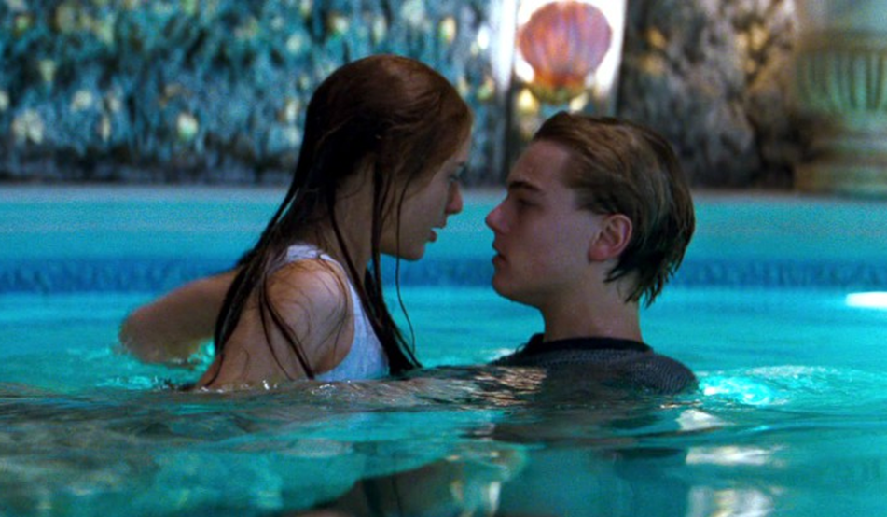

Name: ________________________

‘These violent delights have violent ends…’

PAGE | CONTENT
2 - 3 | Mark Scheme
4 | Essay Structure
5 - 8 | Fate and Foreshadowing Extract, Planning Sheet, Revision Sheet
6 | Fate Planning Sheet
7-8 | Fate and Foreshadowing Revision Sheet
8 | Family Relationships Extract
9-10 | Family Relationships Planning Sheet
11-12 | Family Relationships Revision Sheet
13 | Love Extract
14 | Love Planning Sheet
15-16 | Love Revision Sheet
17 | Romeo Extract
18 | Planning Sheet
19 | How is Romeo presented?
20-21 | Quote Grid

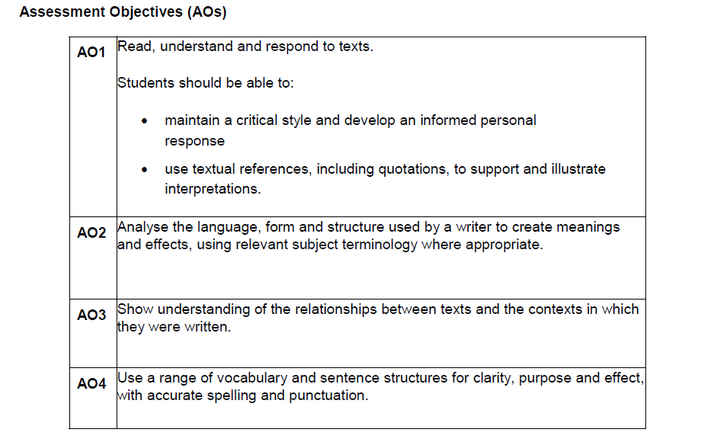

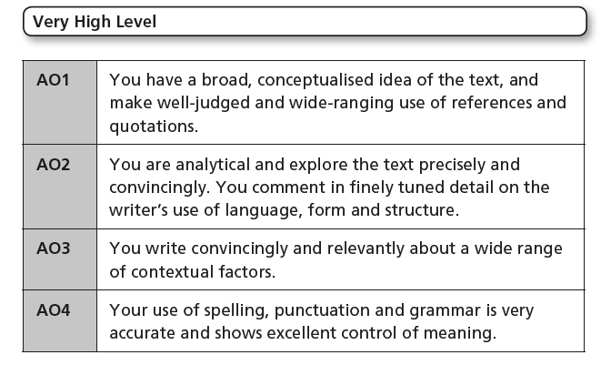
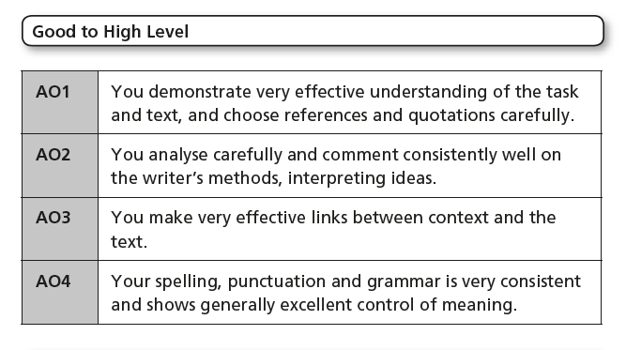
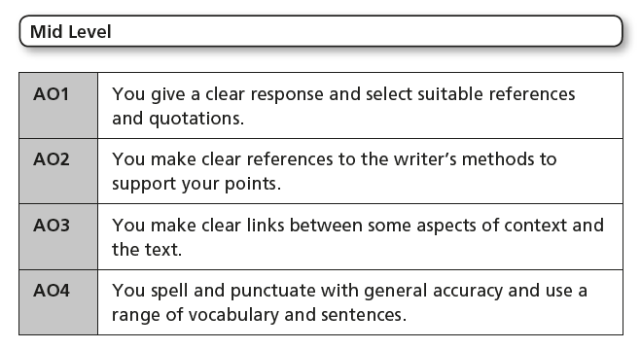
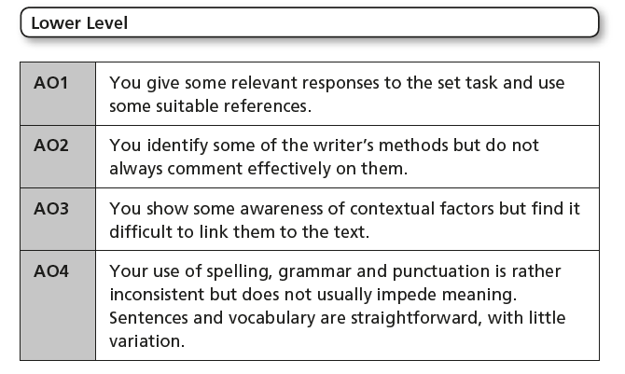
R&J Essay Structure
Introductory Paragraph:
- Give a brief overview of who this character is / what this theme is. Sum up what the extract is about.
- Introduce any important contextual factors
- Introduce your main argument – how is this character/theme presented in this extract and in the rest of the play? Back up your idea with one or two quotes.

Structural Paragraph
N.B. When you refer to other parts of the play for structure, you could talk about how this extract fits into the wider plot of the play e.g. If the extract is the balcony scene and the question is asking you to look at how love is presented, you could contrast Shakespeare’s imagery of love in this scene to other images of love in the play such as death/darkness imagery.
- What structural feature does Shakespeare use in the extract and how does its use support your main argument?
- Example/reference from the extract
- Analyse
- Add in any context if relevant
- Connect to a similar structural feature used or a scene from a different part of the play. Include examples and analyse their effect.
- Link back to your main argument.

Language Paragraph
- What language feature does Shakespeare use in the extract and how does it support your main argument?
- Example/reference from the extract
- Analyse effect – zoom in on single-word and if possible, give different interpretations
- Add in any context if relevant
- Link back to main argument

Language Paragraph – Other parts of the play
- What language feature does Shakespeare use to present this theme/character in other parts of the play? How does it support your main argument?
- Example/reference from extract
- Analyse effect – zoom in on single-word and if possible, give different interpretations
- Add in any context if relevant
- Link back to main argument
Language Paragraph 3 – Extract and/or other parts of the play
- What language feature does Shakespeare use to present this theme/character in the extract and/or in other parts of the play? How does it support your main argument?
- Example/reference from the extract or other parts of the play.
- Analyse effect – zoom in on single-words and if possible, give different interpretations
- Add in any context if relevant
- If focused on extract, see if you can connect to other examples from the rest of the play
- Link back to main argument
Phrases to Introduce the TECHNIQUE + QUOTE:
Exemplary of this is the use of [technique] such as [insert quote]
Here, the use of [technique] is demonstrated through the quote_____
Indeed, this is achieved through the technique_____; for example [insert quote]
Phrases to ANALYSE (what a quote ‘shows’):
Shows
Delineates
Demonstrates
Illustrates
Conveys
Intensifiers (phrases to emphasise your idea!):

Fundamentally
Indeed
Significantly
Importantly

Systematically
Positively
Negatively
Demonstrably
Potentially
Augments
Enhances
Reinforces

Embellishes

Propagates

Phrases to ANALYSE FURTHER ( make a similar point to one already made)

Strengthens

Amplifies

Magnifies

Expands

Symbolises
Signifies
Connotes
Suggests
Alludes
Implies
Indicates
Denotes
Highlights
Communicates
Q: How are themes of fate and destiny presented in this extract from Act 5 Scene 3?
Write about:
- How Romeo and Juliet’s fate is presented here
- How the theme of fate has been presented throughout the play
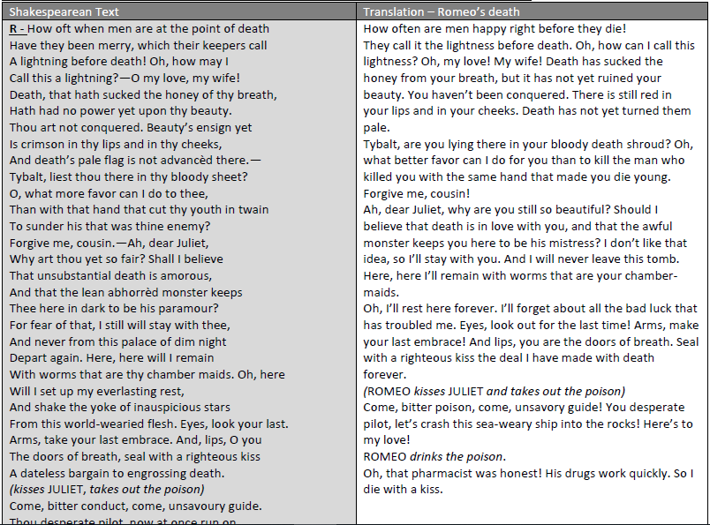

Planning Sheet
MAIN ARGUMENT/GOLDEN THREAD: How is fate presented in this extract? Use quotes to back up your answer.

SECTION | TECHNIQUE | CONTEXT | QUOTE | ANALYSIS
Structure
Language
Language
Language

Revision Sheet: Fate and Foreshadowing in Romeo & Juliet
CONTEXT (AO3):
- Despite being a religious society, most Elizabethans believed in the ideas of fate and astrology.
- Rich people often paid for horoscopes for their children, and before major decisions such as marriage or travel, one would often consult an astrologer to see if the stars favoured it.
- Many people believed that they had no free will: that they had no choice to change their destiny because everything was already ‘predestined’.

ROLE OF FATE AND FORESHADOWING (AO1):
QUOTES AND TECHNIQUES (AO2):
- As an audience, we know from the beginning of the play that Romeo and Juliet are ‘star cross’d lovers’ and fated to die to ‘bury their parents’ strife.’
- Throughout the play, both characters make references to their deaths.
- Shakespeare also makes use of foreshadowing, such as with Friar Lawrence’s opening monologue where he describes how plants can be used to cure but can also be misused to kills, as ‘virtue itself turns vice.’
- Linked to this, Shakespeare uses structure to make the audience aware of the characters’ fate before the characters themselves – only the audience knows why Romeo won’t fight Tybalt in Act 3 Sc. 1 whilst in Act 5 Sc.1 the audience knows that Juliet is not dead whilst Romeo is told that she is.
- Finally, Shakespeare makes plenty of references are made to stars as determiners of the characters’ fight.

TECHNIQE | SCENE | QUOTE | Other Technique
References to stars | Prologue | ‘star cross’d lovers’ | Foreshadowing  Metaphor
 | 5.1  5.3 | On learning of Juliet’s ‘death’, Romeo cries ‘I defy you, stars!’  By Juliet’s deathbed, Romeo says ‘O here/ Will I set up my everlasting rest / And shake the yoke of inauspicious stars.’ | Personification
References to death | 1.5 | Upon seeing Romeo, Juliet remarks “If he [Romeo] be married, my grave is like to be my wedding bed.” | Foreshadowing  Simile
 | 3.4 | As Romeo leaves for Mantua, Juliet remarks that he looks ‘dead in the bottom of a tomb. Either my eyesight fails or thou look’st pale.’ | Foreshadowing  Imagery
Dramatic irony | 3.1 | Romeo refuses to fight Tybalt by saying ‘And so, good Capulet, which name I tender/ As dearly as mine own, be satisfied’
 | 5.1 | Balthasar (Romeo’s man) tells Romeo that Juliet’s ‘body sleeps in Capel monument/ And her immortal part with angels live’ | Religious imagery
 | 5.3 | Romeo comments that still in death Juliet has colour ‘Is crimson in thy cheeks /And death’s pale flag is not advanced there.’ | Metaphor / Personification
Other  Foreshadowing | 2.3 | Friar Lawrence talks of how ‘Within this infant rind of this small flower/  Poison hath residence and medicine power.’ | Metaphor
 | 5.1 | Romeo in Mantua dreams that ‘my lady came and found me dead’ but she ‘breathed such life with kisses in my lips/That I revived and was an Emperor….’

Q: How is Lord Capulet presented in this extract and how are parent-child relationships presented in the play as a whole?
Write about:
- How Lord Capulet is presented here
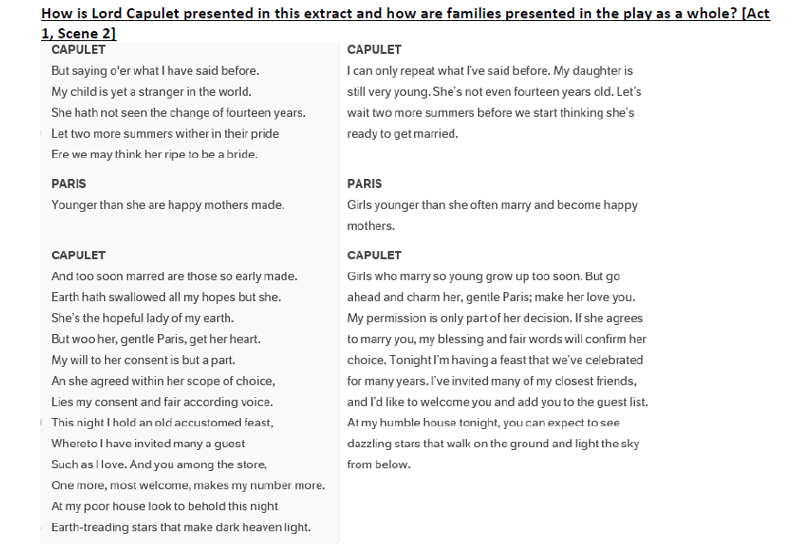
- How parent-child relationships are presented elsewhere

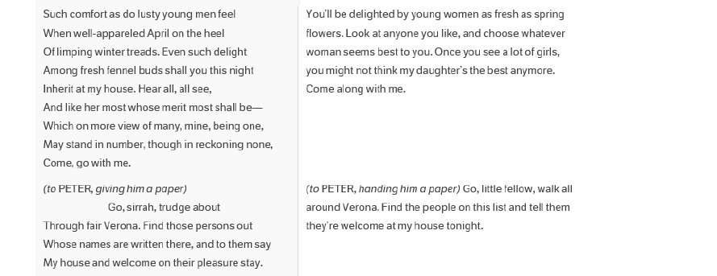

Planning Sheet
MAIN ARGUMENT/GOLDEN THREAD: How is fate presented in this extract? Use quotes to back up your answer.

SECTION | TECHNIQUE | CONTEXT | QUOTE | ANALYSIS
Structure
Language
Language
Language

Revision Sheet: Family Relationships in Romeo & Juliet
CONTEXT (AO3):
- The father was the head of the household in this patriarchal society.
- Women had no rights or authority in law: they could not own property or money but could influence their husbands.
- Children were regarded as property and could be given in marriage to a suitable partner. This was often a political or financial transaction to secure and retain wealth.
- It was not unusual to be married very young.
- In high society, children were often raised by a ‘wet nurse’ and did not have a strong bond with their parents.

ROLE OF FAMILY AND PARENT-CHILD RELATIONSHIPS (AO1):
- An underlying theme of the play is how the characters of Romeo and Juliet defy their parents and families’ wishes (like any normal teenager) by trying to carve out their own path.
- Lord Capulet is initially presented as a protective father considerate of his daughter’s feelings; he desires for Paris to ‘woo’ Juliet and that her ‘consent’ will greatly influence his decision to allow Paris and Juliet to marry.
- This contrasts to Act 3 Sc. 5, where Lord Capulet threatens to disown Juliet as a ‘disobedient wretch’ when she refuses to marry Paris. His transformation from a caring father to threatening to ‘drag’ her to the Church is perhaps points to how Shakespeare is making the point that the most of the adults of the play use their children for self-serving purposes – whether it is to make strategic alliances through marriage (Lord Capulet) or using them to attempt to end the feud (Friar Lawrence)
- Shakespeare uses adults to portray unromantic depictions of love that contrasts to R+J’s ‘love at first sight’ and ‘sacred’ true love. Lady Capulet is portrayed to have a cold attitude to love and marriage, only speaking of Paris’s social position and wealth rather than asking how Juliet feels. The Nurse represents a more physical attitude towards love, making plenty of sexual jokes and puns, that contrasts with Juliet’s innocent romance.
- Both Romeo and Juliet are depicted to have stronger relationships with adults that are not their parents.
  - Juliet has a close relationship with her nurse, to the extent that Juliet’s own mother relies on the Nurse to most of the parenting, bidding her to ‘come back again’ when talking in 1.3
  - Romeo goes to Friar Lawrence for fatherly advice in 2.3

QUOTES AND TECHNIQUES (AO2):

TECHNIQE | SCENE | QUOTE | Other Technique
Contrast - Affectionate Lord Capulet versus Angry Lord Capulet | 1.2 | ‘And too soon marred are those so early made/ Earth hath swallowed up all my hopes but she;’  ‘And she agreed, within her choice/Lies my consent and fair-according voice.’ | Personification  Rhyming couplet
 | 3.5 | ‘To go with Paris to Saint Peter’s Church, Or I will drag thee on a hurdle thither.’  ‘An you be not, hang, beg, starve, die in the streets/ For by my soul I’ll ne’er acknowledge thee.’ | Violent verb  Asyndetic listing
Possessive Language | 1.2 | Lord Capulet – ‘Let two more summers wither in their pride/ before we may think her ripe to be a bride’ | Personification  Metaphor
 | 1.3 | Lady Capulet – ‘So shall you share all that he doth possess/ By having him, making yourself no less.’ | Rhyming couplets  Metaphor
 | 3.5 | Lord Capulet – ‘As you’ll be mine, I’ll give you to my friend.’ | Caesura
 | 2.3 | Friar Lawrence refers to Romeo as ‘pupil mine’ and ‘young son.’
Sexual language | 1.3  2.5 | Nurse – ‘go seek happy nights to happy days’  ‘by which your love/must climb a bird’s nest soon when it is dark’  ‘you shall bear the burden soon at night’ | Metaphor
Angry tone | 1.5 | Lord Capulet to Tybalt ‘You must contrary me!........ You are a princox: go/ be quiet or……I’ll make you quiet’ | Enjambment  Exclamation
 | 5.1 | Lord Capulet to Juliet ‘How, will she none? Doth she not give us thanks? / Is she not proud? Doth she not count her blest….’  ‘Out, you green sickness carrion! Out you baggage, / You tallow-face!’ | Rhetorical question  Caesura  Exclamation

Q: How does this extract present Romeo’s feelings of love and how is the theme of love presented throughout the play?

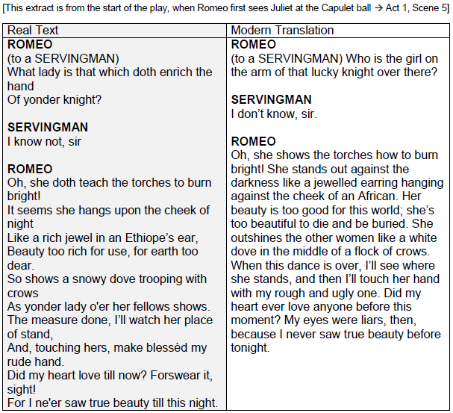

SECTION | TECHNIQUE | CONTEXT | QUOTE | ANALYSIS
Structure
Language
Language
Language

Revision Sheet: Love in Romeo & Juliet
CONTEXT (AO3):
- To marry for love was highly uncommon for aristocratic families like the Montagues and Capulets
- Rather, marriage was often a political or financial transaction to secure and retain wealth.
- Courtship between aristocratic couples or courtly love (like royalty) should be polite, ceremonious, restrained, intellectual, courteous and those involved should be in love with the idea of being in love
- Romeo is initially presented as a Petrarchan lover – Petrarch was a 14th century Italian poet who was greatly admired by writers and playwrights during Shakespeare’s time.
- A Petrarchan lover can be described as melodramatic and self-consciously suffering as his feelings of love are not reciprocated by the lady he admires.
- Religious references are often used to describe Romeo & Juliet’s love – Elizabethan society was at the time had undergone major religious and political upheaval having split from the Catholic Church to form its own Protestant Church of England.
- Europe was a traditionally Catholic society with a strong belief in damnation for mortal sin. Suicide and bigamy were both considered to be mortal sins.

ROLE OF LOVE (AO1):
- Introduced to the theme of love when we first meet Romeo who is lamenting over his unrequited love for Rosaline. Later in this scene, it becomes clear that Romeo is most upset because Rosaline won’t sleep with him – she is ‘in strong proof of chastity well armed, / From Love’s weak childish bow she lives unharmed.’
- Romeo forgets his feelings for Rosaline when he lays eyes on Juliet – ‘Did my heart love till now? Forswear it sight! / For I never saw true beauty until this night!’
- Shakespeare frequently uses light imagery to present the couple - light symbolises Romeo & Juliet’s love for each other.
- But this also contrasts with images of darkness to remind the audience that it is a doomed relationship – they have to keep their love a secret and can only be together when there’s ‘night’s cloak to hide’ them.
- Religious imagery is also used to describe their love, particularly when they first meet. Shakespeare’s frequent references to purity (through light) and their love being sacred could be an attempt to portray their love as a religion in order to overcome the fact that they commit a mortal sin.
- Other adults do not believe that their love is genuine. Friar Lawrence perceives Romeo as fickle – ‘Young men’s love lies/ Not truly in their hearts, but in their eyes’ - whilst the Nurse thinks Juliet has made a poor choice – ‘Well you have made a simple choice/ You know not how to choose a man.’
- Finally, ‘love’ is portrayed to be closely intertwined with death – Juliet comments upon seeing Romeo that her “grave is like to be my wedding bed.”

QUOTES AND TECHNIQUES (AO2):

TECHNIQE | SCENE | QUOTE | Other Technique
Rhyming couplets | 1.1 | ‘in strong proof of chastity well armed, / From Love’s weak childish bow she lives unharmed’ – Romeo about Rosaline | Personfication
 | 1.5 | ‘Did my heart love till now? Forswear it sight! / For I never saw true beauty until this night!’ – Romeo | Personification  Rhetorical question
Rhyme and sonnet form | 1.5 | Romeo and Juliet’s first exchange together makes up 14 lines before they kiss. Romeo first speaks in rhyme scheme of ABAB and Juliet speaks in rhyme scheme of CBCB
Religious imagery | 1.5 | ‘If I profane with my unworthiest hand/ This holy shrine, the gentle sinner is this/ My lips, two blushing pilgrims, ready stand’ – Romeo  ‘Good pilgrim you do wrong your hand too much’ – Juliet | Metaphor
 | 2.2 | ‘O speak again, bright angel, for thou art/ As glorious to this night, being o’er my head, / As is a winged messenger of heaven..’ – Romeo  ‘swear by thy gracious self, / which is the god of my idolatry,’ - Juliet | Simile  Enjambment  Metaphor
Light imagery | 2.2 | ‘But soft, what light through yonder window breaks? / It is the east, and Juliet is the sun’ – Romeo  Romeo describes Juliet’s eyes as ‘two of the fairest stars in all of heaven’ and that ‘the brightness of her cheek would shame those stars.’  Juliet uses the image of lightning saying it is ‘too sudden, / too like the lightning, which doth ceases to be.’ | Metaphor  Rhetorical question  Personification  Metaphor  Simile
 | 5.3 | By Juliet’s deathbed, Romeo says ‘O here/ Will I set up my everlasting rest / And shake the yoke of inauspicious stars.’ | Personification
Imagery of darkness / death | 1.5 | Upon seeing Romeo, Juliet remarks “If he [Romeo] be married, my grave is like to be my wedding bed.” | Foreshadowing  Simile
 | 2.2 | ‘I have night’s cloak to hide me from their [Capulet] eyes’ - Romeo | Personification
 | 3.5 | Juliet pretends that it is still dark as she does not want Romeo to leave ‘Wilt thou be gone? It is not yet day:/ It was the nightingale and not the lark’ | Caesura  Natural imagery
 | 5.3 | Romeo – ‘Shall I believe/ that unsubstantial death is amorous/ And that the lean abhorred monster keeps / thee here in the dark to be his paramour?’ | Personification  Enjambment  Rhetorical Q
Oxymoron | 1.1 | ‘O brawling love, O loving hate’ ‘O heavy lightness, serious vanity’ ‘Feather of lead, bright smoke, cold fire, sick health’
Natural Imagery | 2.2 | ‘My bounty is as boundless as the sea, / My love as deep; the more I give to thee,/ The more I have: for both are infinite’ - Juliet | Caesura  Simile
 | 5.3 | ‘Sweet flower, with flowers thy bridal bed I strew’ - Romeo

Q: To what extent does Shakespeare present Romeo as a foolish and naïve character?

SECTION | TECHNIQUE | CONTEXT | QUOTE | ANALYSIS
Structure
Language
Language
Language

Who is Romeo as a character?

How is Romeo presented in this extract?
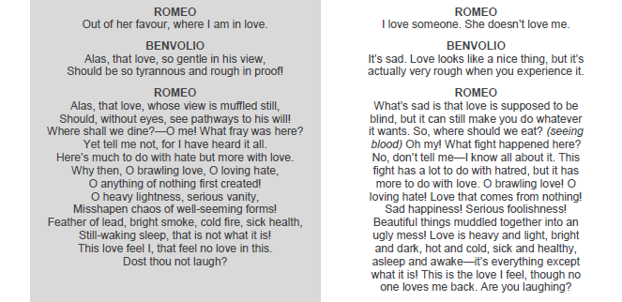

Romeo | SCENE | Quote | How does Shakespeare use language/structure? | How does it present Romeo?
Romeo is romantic | 2.2 | ‘Romeo describes Juliet’s eyes as ‘two of the fairest stars in all of heaven’ and that ‘the brightness of her cheek would shame those stars.’
Romeo is fickle | 5.1 | ‘Did my heart love till now? Forswear it sight! / For I never saw true beauty until this night!’
Romeo is emotional | 5.1 | Friar – ‘Hold thy desperate hand! Art thou a man? …. Thy tears are womanish’
Romeo is impulsive | 5.3 | On learning of Juliet’s ‘death’, Romeo cries ‘I defy you, stars!’

