GCSE Literature Paper 2

Unseen Poetry Booklet
SUCCESS CRITERIA | PRE-RAG RATING | POST-RAG RATING
I can spot particular word choices in poems e.g. verbs, adjectives, adverbs
I can spot ACOMPASS techniques in poems
I can include quotes from poems in my answers
I can spot structure of a poem e.g. stanzas, rhyme scheme, rhythm
I can spot structural techniques e.g. sibilance, caesura, enjambment
I can explain the connotations of word choices in a poem
I can explain the effect of ACOMPASS techniques
I can explain why the poem has a particular structure
I can explain the effect of structural techniques
I can give a second interpretation of a quote and/or a second quote
EBI:

WWW:

What should I look for in a poem?
LANGUAGE
Word choice:
- Verbs
- Adjectives
- Adverbs
Imagery:
- Personification
- Metaphor
- Symbols or images
Other techniques:
- Simile
- Alliteration / sibilance
- Onomatopoeia
Exposure by Wilfred Owen

STRUCTURE / FORM
Rhythm and Rhyme:
- Is there a regular beat?
- Do the lines rhyme?

Stanzas:
- How many stanzas are there?
- Do the stanzas have the same length?
- Do the stanzas say the same tense?
- Is there a cyclical or linear structure?

Other techniques:
- Enjambment
- Caesura
- Repetition

Exposure
BY WILFRED OWEN
Our brains ache, in the merciless iced east winds that knive us . . .
Wearied we keep awake because the night is silent . . .
Low drooping flares confuse our memory of the salient . . .
Worried by silence, sentries whisper, curious, nervous,
But nothing happens.

Watching, we hear the mad gusts tugging on the wire,
Like twitching agonies of men among its brambles.
Northward, incessantly, the flickering gunnery rumbles,
Far off, like a dull rumour of some other war.
What are we doing here?

The poignant misery of dawn begins to grow . . .
We only know war lasts, rain soaks, and clouds sag stormy.
Dawn massing in the east her melancholy army
Attacks once more in ranks on shivering ranks of grey,
But nothing happens.

Sudden successive flights of bullets streak the silence.
Less deadly than the air that shudders black with snow,
With sidelong flowing flakes that flock, pause, and renew,
We watch them wandering up and down the wind's nonchalance,
But nothing happens.

THEME | WORD /PHRASE | Connotations – what does the word/phrase make you think/feel/imagine? How does it present the weather/sound/violence?
Weather | ‘merciless iced East winds’ | ‘Merciless’ makes me think the wind is unforgiving  ‘Iced’ makes me think that it is very cold
 | ‘Mad gusts’
Violence | ‘streak’
 | ‘agony’
 | ‘twitching’
Sound | ‘silence’
 | ‘rumbles’

Quotation Explosion

I DO – Copy what I do

“merciless iced East winds that knife us”

WE DO - Teamwork
“Watching, we hear the mad gusts tugging on the wire / Like twitching agonies of men among its brambles”

YOU DO – Independent Work
“Sudden successive flights of bullets streak the silence”

YOU DO – Independent Work
“Less deadly than the air that shudders black with snow”

Literature Paper 2 – What is it?
English Literature GCSE
- English Literature Paper 2:
  - Section A = Animal Farm
  - Section B = War and Conflict Poetry
  - Section C = Unseen Poetry
- Given two poems you would have never seen before. Asked two questions
  - Look at one poem only. Ask to analyse how something is presented – a theme/a person/ a feeling (24 marks)
  - Compare the similarities and differences in the way the two poems present something (8 marks)
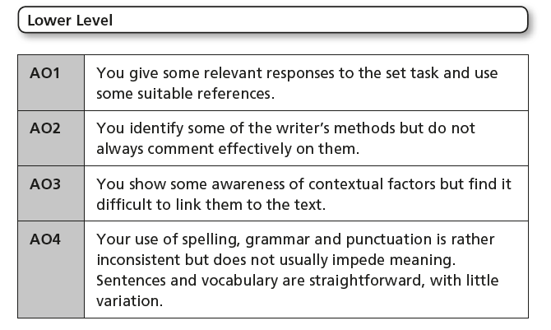
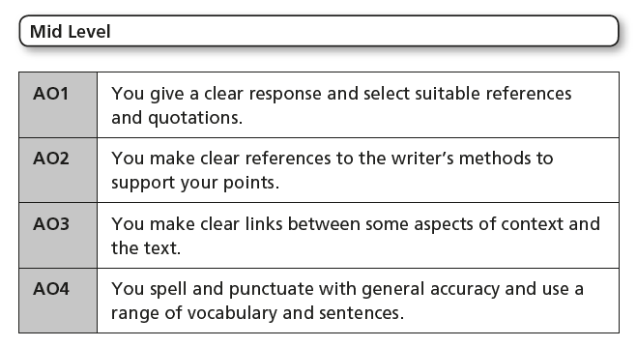
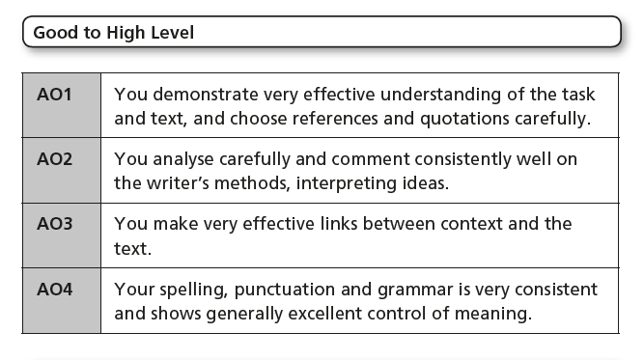

Autumn
By Alan Bold
Autumn arrives
Like an experienced robber
Grabbing the green stuff
Then cunningly covering his tracks
With a deep multitude
O colourful distractions.
And the wind,
The wind is his accomplice
Putting an air of chaos
Into the careful diversions
So branches shake
And dead leaves are suddenly brown
In the faces of inquisitive strangers.
The theft chills the world
Changes the tempers of the earth
Till the normally placid sky glows red with a quiet rage.

Model Essay - In ‘Autumn’, how does the poet present the effects of the season of autumn?

In the poem ‘Autumn’ by Alan Bold, the poet presents the season in a negative light. For example, Bold uses a simile to compare autumn to “like an experienced robber”. This simile implies that the season is almost committing a crime by taking away the green leaves from the trees. The adjective “experienced” implies that the season is very good at stealing. The whole poem is an extended metaphor that presents autumn as stealing the beauty from the world. The alliterative phrase “cunningly covering his tracks” talks about autumn as if it was conscious about what it is doing and is actually taking away the beauty on purpose. This makes autumn sound selfish as it is presented as stealing the greenery for its own gain.
Another way that the poet presents the effects of autumn is by depicting it as destructive, writing how “The wind is his accomplice”. This metaphor implies very strong imagery of the wind sweeping in at the start of autumn and blowing all the dead leaves off their branches and into mini hurricanes. This is one of the main symbols that autumn has arrived so it is easy for the reader or listener to imagine the sight of the autumn leaves. It also conveys that the wind is also conscious of the fact that it is working together with autumn to assist in the theft of green.
A final way in which the poet presents the negative effects of autumn is how at the end of the poem the sky is described as glowing “red with a quiet rage”. This is also powerful imagery of an autumn sky with thick clouds. The oxymoron “quiet rage” suggests that autumn acts with silence, almost unnoticed by some but it affects the world in a massive way. The quote “the theft chills the world” is unclear because it could mean that the autumn makes the world colder. However, it could have a deeper moral meaning saying that crime actually takes the warmth out of the world.

QUOTE | TECHNIQUE | ANALYSIS – what does it make you think/feel/imagine?
‘But nothing happens’ | Repetition | Repeats phrase to reinforce that impatient or worried feeling of waiting and not knowing what might happen next – there is no action or fighting
Q: How is war presented in the poem Exposure?
MAIN ARGUMENT: The poet Owen presents war as ________________________________________

 | Children in Wartime |  | Exposure
 | Idea | Quote | Idea | Quote
SIMILARITIES | War is presented as a fearful experience | ‘it seemed the sky lay broken on my floor’ | War is presented as a fearful experience | ‘Worried by silence, sentries whisper, curious, nervous’
DIFFERENCES
Q2: Both ‘Children in Wartime’ and ‘Exposure’ describe the experience of war. What are the similarities and/or differences in the way the poets present war?
Quotation Explosion

I DO – Copy what I do

WE DO - Teamwork

YOU DO – Independent Work

YOU DO – Independent Work

Today
BY BILLY COLLINS
If ever there were a spring day so perfect,
so uplifted by a warm intermittent breeze

that it made you want to throw
open all the windows in the house

and unlatch the door to the canary's cage,
indeed, rip the little door from its jamb,

a day when the cool brick paths
and the garden bursting with peonies

seemed so etched in sunlight
that you felt like taking

a hammer to the glass paperweight
on the living room end table,

releasing the inhabitants
from their snow-covered cottage

so they could walk out,
holding hands and squinting

into this larger dome of blue and white,
well, today is just that kind of day.

Q2: In both ‘Today’ and ‘Autumn’ the speakers describe attitudes towards the
seasons. What are the similarities and/or differences between the ways the poets present these attitudes?
Both poems create characters to enhance the narrative they are presenting. For example, ‘Autumn’ creates “an experienced robber” and ‘Today’ depicts the “inhabitants” of a “glass paperweight”. The effect of this is that the poems each have a surreal atmosphere when the characters are introduced, yet not so much that it is too far-fetched to be understood by the reader.

Where ‘Autumn’ is negative towards the season it describes (describing “dead leaves” and “quiet rage”), ‘Today’ is overwhelmingly positive. The latter does not appear to have any hints of negativity except for, perhaps, the destructive behaviour that is described. It speaks of “rip[ping] the little door from its jamb”, which suggests that their feelings are so strong that they must be suppressed physically.

Both poems talk about seasons in different ways. Both have no rhyming patters which presents freedom of nature but in ‘Autumn’ also the evil of nature. ‘Autumn’ is set out in one full text whereas ‘Today’ is set out in pairs of lines which could represent the bright and happy nature of the season of spring.

